RESUME
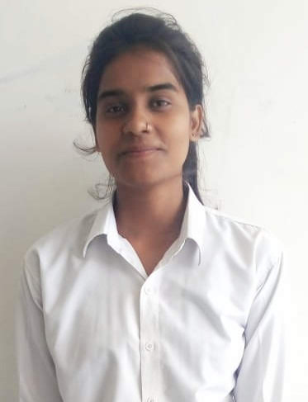
Paste here
Passport size
Photo

Santoshi Kushawaha
Contact no : 8979547808, 6392076989
Email ID: santoshi8979@gmail.com

Career Objective
To make use of my interpersonal skills to achieve goals of a company that focuses on customer satisfaction and customer experience and where I can grow my career by learning new technologies.

Educational Qualifications
QUALIFICATIONS | UNIVERSITY /BOARD | YEAR OF PASSING | PERCENTAGE
B. C. A. | CSJM university | 2020 | 60%
Intermediate | U. P. Board | 2017 | 75.5 %
High school | U. P. Board | 2015 | 75%

Strengths
- Self motivated
- Confident
- Quick Learne
Technical Skills
- Good Understanding of Web development concepts.
- Proficient in oops programming.
- Good knowledge of technologies like PHP, Javascript, Mysql, HTML, CSS.

Extra Curriculum Skills
- MS Office, MS Excel, Powerpoint
- C Programming, C++, Java
Hobbies
- Interested in learning new things.
- Spending time on online learning.
Personal Profile
Father’s name : Mr. Saroj kumar
Mother’s name : Mrs. Dharmendr kumari
Date of birth : 01/01/2001
Address : Yakubpur, Auraiya , Uttar Pradesh, India
Marital status : Single
Nationality : Indian
Language known : Hindi, English
Declaration
I hereby declare that the information given here with is correct to my knowledge and I will be responsible for any discrepancy.
(SANTOSHI KUSHAWAHA)

